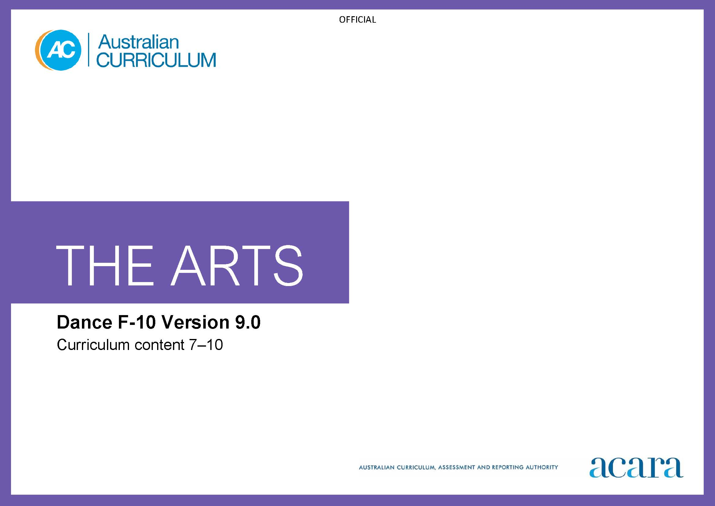

Copyright and Terms of Use Statement
© Australian Curriculum, Assessment and Reporting Authority 2022
The material published in this work is subject to copyright pursuant to the Copyright Act 1968 (Cth) and is owned by the Australian Curriculum, Assessment and Reporting Authority (ACARA) (except to the extent that copyright is held by another party, as indicated).
The viewing, downloading, displaying, printing, reproducing (such as by making photocopies) and distributing of these materials is permitted only to the extent permitted by, and is subject to the conditions imposed by, the terms and conditions of using the ACARA website (see, especially, clauses 2, 3 and 4 of those terms and conditions). The terms and conditions can be viewed at https://www.acara.edu.au/contact-us/copyright

TABLE OF CONTENTS
Curriculum elements 4
Years 7–8 4
Years 9–10 9

Curriculum elements

Years 7–8
Band level description
In this band, learning in Dance builds on each student’s prior learning and experiences. Students learn in and through the practices of Dance: choreography, performance and responding. They use dance-specific processes in purposeful and creative ways, and continue to develop their connection with and contribution to the world as artist and as audience. They work individually and in collaboration with peers and teachers.
Students explore dance in local, regional, national and global contexts such as dance in countries or regions of Asia, including use of dance in multi-arts, trans-disciplinary or hybrid forms. They take opportunities to engage with living performers and choreographers, and expand their awareness of the diversity of dance practices, genres and/or styles.
In this band, the focus is on students:
- exploring and responding to
  - dance works, the work of performers and choreographers, dance practices across cultures, times and places and/or other contexts; for example, through analysis and practical investigations such as improvisation
  - the diversity of dance choreographed and/or performed by First Nations Australians and how this work demonstrates respect for Indigenous Cultural and Intellectual Property rights
- developing practices and skills
  - creative practices for performance and choreography, considering prior learning, safe dance practice, experience and interests. For example, students may focus on individual and ensemble or genre- or style-specific skills, techniques or processes. They build and refine technical and expressive skills, and skills to manipulate the elements of dance
  - critical practices by taking opportunities to reflect, evaluate or respond to their own work and the work of others; for example, documenting use of a choreographic process or ideas and intentions for a dance work or performance, evaluating their own and others’ responses to dance works, reflecting on development of skills and techniques
- creating/choreographing dance to communicate ideas/intentions as choreographers, using the elements of dance, choreographic devices and form. Students may focus on choreographing in a range of dance styles and forms and/or choreographing for multi-arts, hybrid or trans-disciplinary work such as screen-based or theatrical forms
- presenting and performing dance using technical and expressive skills to communicate their ideas and intentions to audiences; for example, through planned and rehearsed live or streamed performances, as appropriate.

Achievement standard
By the end of Year 8, students analyse how the elements of dance, choreographic devices and/or production elements are manipulated in dance they create and/or experience. They evaluate the ways that dance works and/or performances in a range of styles and/or from across cultures, times, places and/or other contexts communicate ideas, perspectives and/or meaning. They describe respectful approaches to creating, performing and/or responding to dance.
Students manipulate the elements of dance and choreographic devices to choreograph dance that communicate ideas, perspectives and/or meaning. They demonstrate safe dance practice when choreographing and performing dance. They employ technical and expressive skills and, as appropriate, genre- or style-specific techniques when performing dances for audiences.

Strand: Exploring and responding |  | Years 7–8
Content descriptions  Students learn to: | Content elaborations  This may involve students:
investigate ways that dance works, performers and/or choreographers across cultures, times, places and/or other contexts use the elements of dance, choreographic devices and/or production elements to communicate ideas, perspectives and/or meaning  AC9ADA8E01 | - analysing dances from a range of times and locations, such as dances from times they are studying in History or dance from a country or region in Asia, and considering how a single realistic movement can be manipulated from representational to symbolic (literal to abstract)  - investigating the development of dance styles in different artistic, social, environmental, historical or cultural contexts; for example, identifying the distinguishing stylistic features of dances in a range of styles or from a range of times or places, and considering how these can inform their choreography  - using Viewpoints to explore questions such as “What was the choreographer’s intention for this dance?”, “What ideas did you think the dance expressed?”  - comparing use of one or more elements of dance and/or choreographic devices such as repetition in dances from a range of genres/styles, cultures, times and/or places; for example, dances from a range of cultures or countries in Asia  - investigating how digital tools and use of immersive technologies such as virtual reality (VR) are influencing choreography, performance or use of production elements
investigate the diversity of dance choreographed and/or performed by First Nations Australians considering culturally responsive approaches to Indigenous Cultural and Intellectual Property rights  AC9ADA8E02 | - exploring information about Indigenous Cultural and Intellectual Property rights that is available to help dance practitioners understand how to make ethical choices; for example, asking questions such as “Who created this dance or these movements?”  - using and annotating a map of First Nations Australian language groups to identify where First Nations Australian choreographers and/or performers are working and provide short descriptions of the dance they are choreographing and/or performing  - analysing how linear and non-linear narrative is used in specific examples of dance choreographed and/or performed by First Nations Australians to explore issues such as relationships, identity or empathy  - investigating an example of cultural appropriation where it has been found that First Nations Australian Indigenous Cultural and Intellectual Property rights have been denied and identifying how this situation could have been approached respectfully; for example, a situation where a choreographer has used movement vocabulary that carries cultural knowledge without permission from the knowledge holders

Strand: Developing practices and skills |  | Years 7–8
Content descriptions  Students learn to: | Content elaborations  This may involve students:
develop safe dance practice and use of expressive and technical skills and, as appropriate, genre- or style-specific techniques  AC9ADA8D01 | - developing dance skills and style-specific techniques; for example, experimenting to extend their own movement vocabulary by improvising using movements and techniques from diverse dance styles  - exploring how expressive skills can be used to communicate ideas; for example, using gesture or facial expression to communicate relationships or emotions  - extending technical competence such as control, coordination, accuracy, alignment, balance, flexibility, strength, endurance and articulation when moving, in response to self, peer and/or teacher feedback
reflect on own and others’ dance works and/or practices to inform choreographic choices and use of technical and expressive skills  AC9ADA8D02 | - reflecting on how they have used or extended their movement vocabulary and considering options for further development  - evaluating influences on their own performance or choreography; for example, using a journal to document interesting examples of how others use an element of dance or genre- or style-specific techniques, and considering how to use these ideas in their own choreography or performance  - reflecting on feedback from peers who have observed a workshop or a rehearsal and using ideas from the feedback/reflection to refine dance; for example, use of technical and expressive skills or a choreographic device

Strand: Creating and making |  | Years 7–8
Content descriptions  Students learn to: | Content elaborations  This may involve students:
choreograph dance by selecting and manipulating elements of dance and choreographic devices to communicate ideas, perspectives and/or meaning  AC9ADA8C01 | - exploring ways to use elements of dance and choreographic devices to portray characters and stories respectfully and empathetically  - experimenting with ways to use the elements of dance and choreographic devices to represent ideas about themes or issues such as social relationships through dance; for example, through improvisation  - selecting movements from an improvisation, such as an improvisation focusing on communication of mood or emotion, and organising it for use in a music video or as short phrases that participants in an immersive experience such as VR can use  - selecting, combining, refining and sequencing movement using choreographic devices such as transitions, variation and contrast, and choreographic forms such as binary, ternary and narrative  - analysing and evaluating the structural choices made in their dance by documenting their process in records such as journals, blogs, video or audio recordings, securing permission where appropriate
apply technical and expressive skills and/or genre- or style-specific techniques to communicate ideas, perspectives and/or meaning  AC9ADA8C02 | - applying technical skills such as strength, balance or coordination to intensify communication of mood/atmosphere in a dance they are choreographing and/or performing  - responding to feedback to enhance communication of choreographic intent to the audience; for example, by refining use of technical skills such as accuracy or flexibility  - using questions based on Viewpoints to evaluate clarity of movement, projection, focus and musicality when preparing for a performance, and using video to evaluate and refine spatial placement or articulation

Strand: Presenting and performing |  | Years 7–8
Content descriptions  Students learn to: | Content elaborations  This may involve students:
rehearse and perform dance for audiences, using technical and expressive skills and, as appropriate genre- or style-specific techniques  AC9ADA8P01 | - planning effective use of available performance spaces during rehearsals  - using production elements such as projection, soundscape, music, special effects or voice-overs to share key ideas or information about the creative intention of the dance with the audience  - using technical and expressive skills and, as appropriate, genre- or style-specific techniques when performing dance they have learnt and/or choreographed  - using rehearsal strategies or techniques such as spotting to enhance confidence, clarity of movement, projection, focus and musicality in performance  - introducing their dance to an audience; for example, in a program note or voice-over that uses descriptive style-specific dance terminology

Years 9–10
Band level description
In this band, learning in Dance continues to build on each student’s prior learning and experiences as students develop their capability and confidence across the practices of Dance: choreography, performance and responding. They continue to use dance-specific processes in purposeful and creative ways that are informed by their engagement with the work of living choreographers and performers from across local, regional, national and global cultures, times, places and/or other contexts, such as countries or regions in Asia. This can include use of dance in multi-arts, trans-disciplinary or hybrid forms. This awareness of diverse dance practices, genres and/or styles informs their own work as choreographers and performers. They work collaboratively with peers and teachers.
In this band, the focus is on students:
- exploring and responding to
  - choreographers’ and performers’ use of the elements of dance, choreographic devices, genre/style techniques and/or production elements in works or contexts across cultures, times and/or places; for example, through analysis or practical investigations
  - ways in which dance choreographed and/or performed by First Nations Australians celebrates and challenges multiple perspectives of Australian identity
- developing practices and skills
  - building and extending creative practices for performance and choreography, considering prior learning, safe dance practice, experience and interests. For example, students may continue to develop genre- or style-specific techniques and explore new interests to extend and refine technical and expressive skills
  - building and extending critical practices by taking opportunities to reflect on and evaluate their own work, respond to and analyse their own work
- creating work to communicate ideas and intentions using the elements of dance, choreographic devices and form. They use choreographic processes that are appropriate to the genre/style. As they develop and refine their work, students consider how they can employ technical and expressive skills to communicate ideas, perspectives and/or meaning in their work. Students may focus on choreographing in a range of dance styles and forms, or they may choreograph dance for multi-arts, hybrid or trans-disciplinary works; for example, using immersive technologies
- performing their work using technical and expressive skills and genre- or style-specific techniques to communicate their ideas and intentions to audiences; for example, in planned and rehearsed live or streamed performances.
Achievement standard
By the end of Year 10, students analyse how and/or why the elements of dance, choreographic devices, genre- or style-specific techniques, production elements, and/or technical and expressive skills are manipulated in dance they create and/or experience. They evaluate how dance works and/or performances in a range of styles and/or from across cultures, times, places and/or other contexts communicate ideas, perspectives and/or meaning. They evaluate how dance is used to celebrate and challenge perspectives of Australian identity.
Students select and manipulate the elements of dance, choreographic devices and/or structure to choreograph dances. They demonstrate safe dance practice when choreographing and performing dance. They employ technical and expressive skills and genre- or style-specific techniques to enhance communication of ideas, perspectives and/or meaning when performing dance for audiences.

Strand: Exploring and responding |  | Years 9–10
Content descriptions  Students learn to: | Content elaborations  This may involve students:
investigate performers’ and/or choreographers’ use of elements of dance, choreographic devices, genre- or style-specific techniques, conventions and/or production elements to communicate and/or challenge ideas, perspectives and/or meaning in dance across cultures, times, places and/or other contexts  AC9ADA10E01 | - investigating specific examples of how and why dance practitioners work collaboratively with communities, such as communities in Australia with cultural links to countries and/or regions in Asia  - investigating how and why choreographers work with communities to advocate for sustainable ways of living, social justice and recognition of people or events  - investigating why and how different traditions, styles and contexts affect the experience and interpretation of a dance work and taking this into account when choreographing and performing; for example, using Viewpoints to explore questions such as “What meaning is intended by the choreographer?”, “What cultural traditions are represented in this dance?” or “How does this work relate to my culture? To my life?”  - extending their movement vocabulary as they explore their own stylistic preferences and personal identity; for example, using analysis of dance styles from a range of cultures they identify with or dance styles from different times to inform their choreographic practice  - analysing use of elements of dance in different genres/styles, such as styles that feature in popular culture or from a country or region in Asia, as a stimulus for choreography or to inform performance of a learnt work
investigate the ways First Nations Australian choreographers and/or performers celebrate and challenge multiple perspectives of Australian identity through dance  AC9ADA10E02 | - evaluating ways that First Nations Australian performers and/or choreographers are working respectfully and collaboratively with communities to explore local histories, cultures and identities  - investigating dance works that challenge our understandings about “first contacts” between the First Nations Peoples of Australia and people from Britain or Europe  - exploring the ways that First Nations Australian choreographers and/or performers use their practice to communicate ideas, messages and lived experiences to the broader community

Strand: Developing practices and skills |  | Years 9–10
Content descriptions  Students learn to: | Content elaborations  This may involve students:
develop and refine safe dance practice, expressive and technical skills and genre- or style-specific techniques  AC9ADA10D01 | - refining technical skills in response to self-reflection to develop safe dance practice and control, accuracy, strength, balance, alignment, flexibility, endurance, coordination and articulation  - using experimentation and improvisation to develop techniques for executing expressive skills in a range of genres and/or styles  - practising and refining technical skills to develop proficiency in genre- and style-specific techniques
reflect on own and others’ use of the elements of dance, choreographic devices, structure, genre- or style-specific techniques and/or technical and expressive skills to inform their choreographic or performance choices  AC9ADA10D02 | - using questions based on Viewpoints to reflect on and evaluate use of forms and elements; for example, “How can I use and manipulate the elements of space and dynamics to convey my ideas?”  - evaluating choreographic and/or performance choices; for example, “How successful were the dancers in conveying the choreographer’s stated intent?” or “What was the impact of the performer’s choice to use gesture to communicate emotion?”  - documenting their creative process, including the use of analysis and evaluation strategies, in reflective records  - improvising using the elements of dance and analysing movement choices to reflect their individuality and to clarify their choreographic intent  - considering how they can use the elements of dance and choreographic devices to reflect ways that meaning and experiences, political statements, critical theories or emotions influence and shape their approach to dance

Strand: Creating and making |  | Years 9–10
Content descriptions  Students learn to: | Content elaborations  This may involve students:
choreograph dance that communicates ideas, perspectives and/or meaning by selecting and manipulating elements of dance, choreographic devices and/or structure  AC9ADA10C01 | - experimenting with ways to use and combine choreographic devices, such as addition and diminution, force and tempo or by using different body parts  - using questions based on Viewpoints relating to forms and elements; such as “How can I use and manipulate the elements of space and dynamics to convey my ideas?”, for example, when choreographing a dance that conveys ideas, perspectives or meaning about identity, belonging or a social justice issue  - investigating the use of the elements of dance in works of artists from different cultures, times and places, and adapting dance ideas to create movements that represent a synthesis of influences and present a personal meaning or perspective, using respectful dance practice  - developing movement motifs and using choreographic devices or manipulating the elements of dance in innovative ways to communicate their choreographic intent  - using motifs from a known dance as the starting point for their own choreography; for example, identifying and improvising on movements from a dance being shared via a social media platform to develop ideas that can be extended and structured into new work  - using a style-specific form such as a form associated with a culturally specific dance genre/style, to structure a dance
apply technical and expressive skills and genre- or style-specific techniques to enhance communication of ideas, perspectives and/or meaning  AC9ADA10C02 | - applying knowledge of the structure and function of the musculoskeletal system to execute movements safely and prevent injury to themselves and others  - using observations/analysis of a dance in a selected genre/style to identify characteristic techniques, building ability to execute the technical and expressive skills using safe dance practice over time and applying it to enhance performance of dances  - seeking feedback on their choreography and performance; for example, using Viewpoints to frame questions such as “What emotion did you feel most strongly as you viewed the dance?” and using the feedback to refine use of technical and expressive skills

Strand: Presenting and performing |  | Years 9–10
Content descriptions  Students learn to: | Content elaborations  This may involve students:
rehearse and perform dance for audiences, using technical and expressive skills and genre- or style-specific techniques  AC9ADA10P01 | - planning how they can enter and leave the performance space in ways that are consistent with genre/style, mood or ideas conveyed in a dance  - using rehearsal to build confidence that they can accurately and fluently maintain spatial placement during performance of a dance  - using available production elements such as music, costume and props to enhance communication of ideas, perspectives or meaning in a performance

